
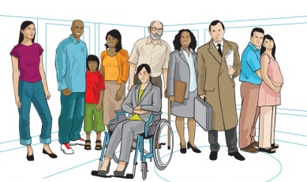
Marazion Surgery
Patient Participation Group

Terms of Reference of the Patient Participation Group

Title of the Group:

- The Group shall be called Marazion Surgery Patient Participation Group (hereinafter referred to as ‘the Group’).

Purpose of the Group:

- The purpose of the Group is to give a voice to patients of Marazion Surgery and to promote co-operation between the Practice and patients to the mutual benefit of both.

- The Group will enable, where appropriate, patients to influence local health care services.

Membership of the Group:

- Membership of the Group shall be open and free to all registered patients and staff of the Practice.

- Members must agree to the Terms of Reference.

- If a member is unable to attend a meeting, they should offer their apologies ahead of the meeting so that a quorum of at least five persons in attendance can be ensured.

- If a member is disruptive or uncooperative within the Group, their membership may be terminated by the Chairperson after consultation with the Group.

- Administrative support for the Group will be provided by the Practice.

- Mrs Benstead, PA to the Management Team at the Practice, will provide a link between the Group and the Practice.

Objectives of the Group:

- Provide feedback about Practice services and make suggestions on how patients’ experiences can be improved.

- Promote health and wellbeing information to patients.

- Review patient feedback annually following patient survey.

- Contribute to Practice decision-making and act as a forum for consultation on service development and provision.

- Represent patients at the Practice in seeking to influence local provision of health and social care.

- Support the Practice in its dealings with other bodies.

- Fundraise for Practice, such as for new or replacement equipment.

- Offer practical support (For example, helping direct parking during vaccination clinics).

Meetings of the Group:

- At least four weeks notice of the date of meetings will be provided. At each meeting the date for the next meeting will usually be agreed.

- The Agenda and related documents will be circulated by Email at least one week prior to the meeting.

- Meetings will be held at intervals determined by the group. Working party groups may meet separately and report back.

- Notices of meetings, Minutes of meetings and information about the Group will be displayed on the noticeboard in the Practice and on the Practice website.

- Members will agree to treat items discussed as confidential as appropriate.

- A quorum of three would be required to conduct the business of the group. Contentious issues or proposals could be circulated to all members of the group by email so that all would have opportunity to voice their opinion.

- Ground rules of the Group will be adhered to:

- The group is not a forum for individual complaints and single-issue concerns.
- We advocate open and honest communication and respectable challenge between individuals.
- We will be flexible, listen, ask for help and support each other.
- We will demonstrate a commitment to delivering results, as a group.
- Silence indicates agreement – speak up, but always go through the Chair.
- All respectable views are valid and will be listened to.
- Offensive and discriminatory language will not be tolerated.
- No phones or other disruptions.
- We aim to start and finish on time and stick to the Agenda.

February 2023

